|  |
| --- |
|  |
| SkillVerse |
| C:\Users\fahad.murtaza\Desktop\web project\logo.jpg |
|  |

Table of Contents

1. Create User 2

2. Login User 3

3. Create Book 4

4. Get All Books 5

5. Get Book by ID 6

6. Update Book 7

7. Delete Book 8

# Create User

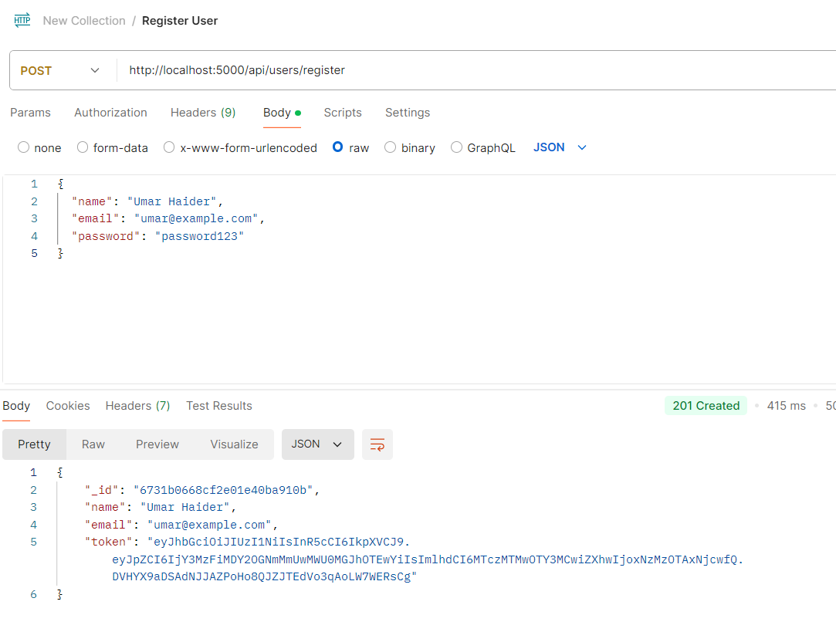

# Login User

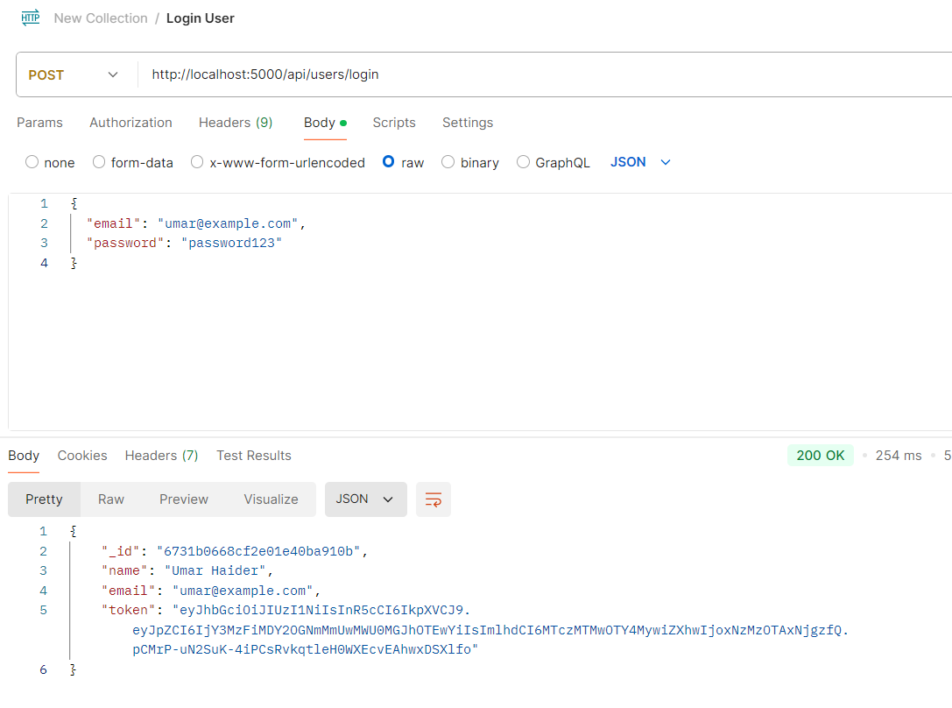

# Create Book

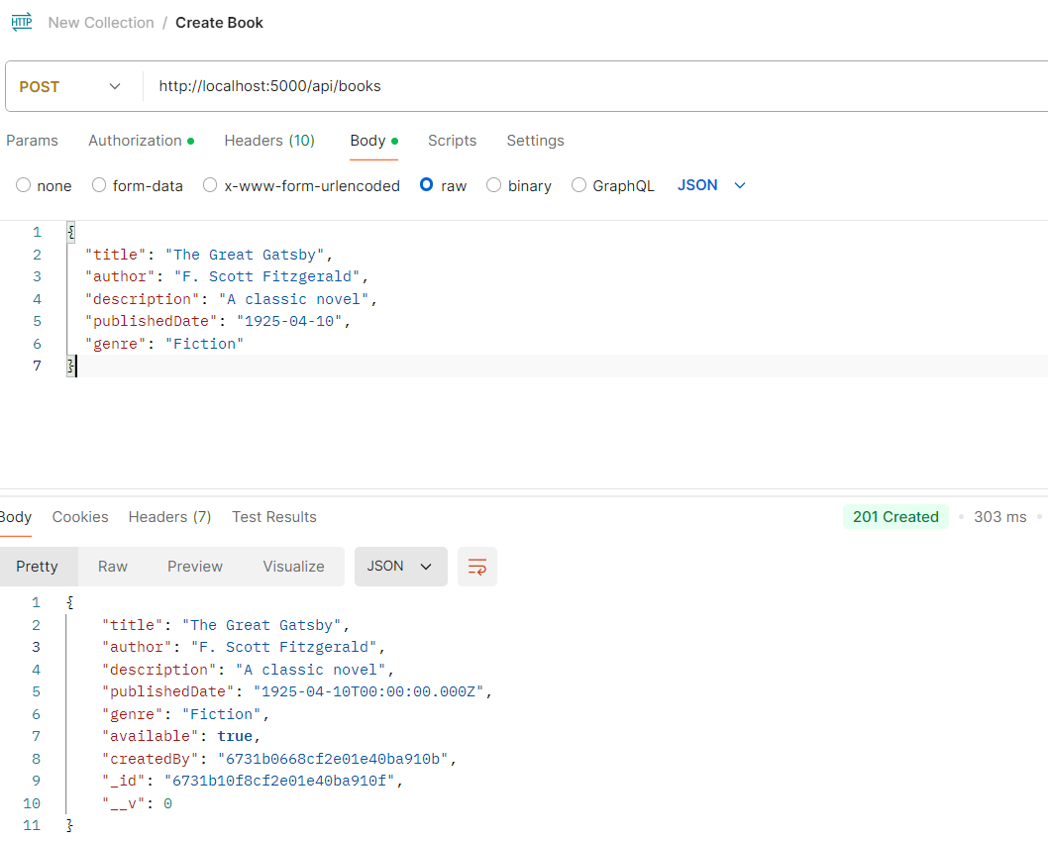

# Get All Books

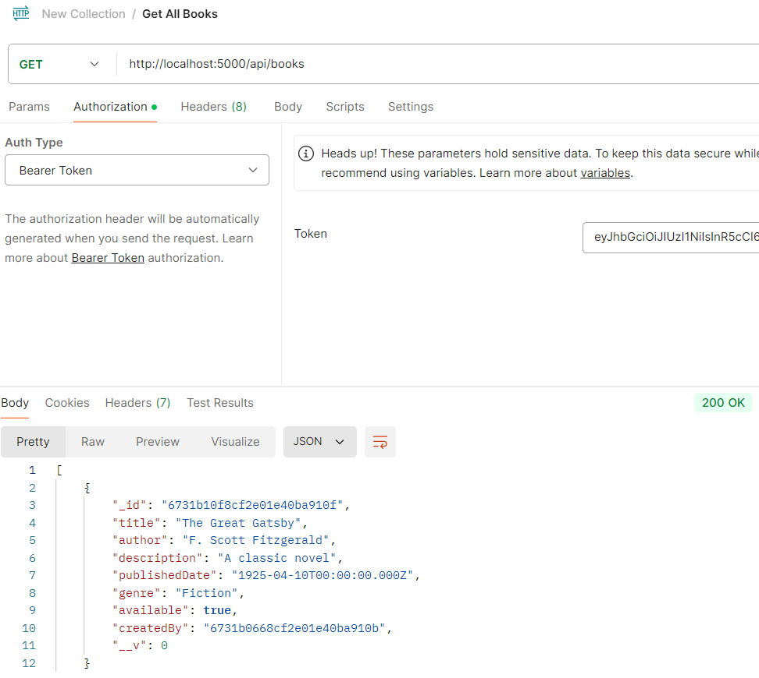

# Get Book by ID

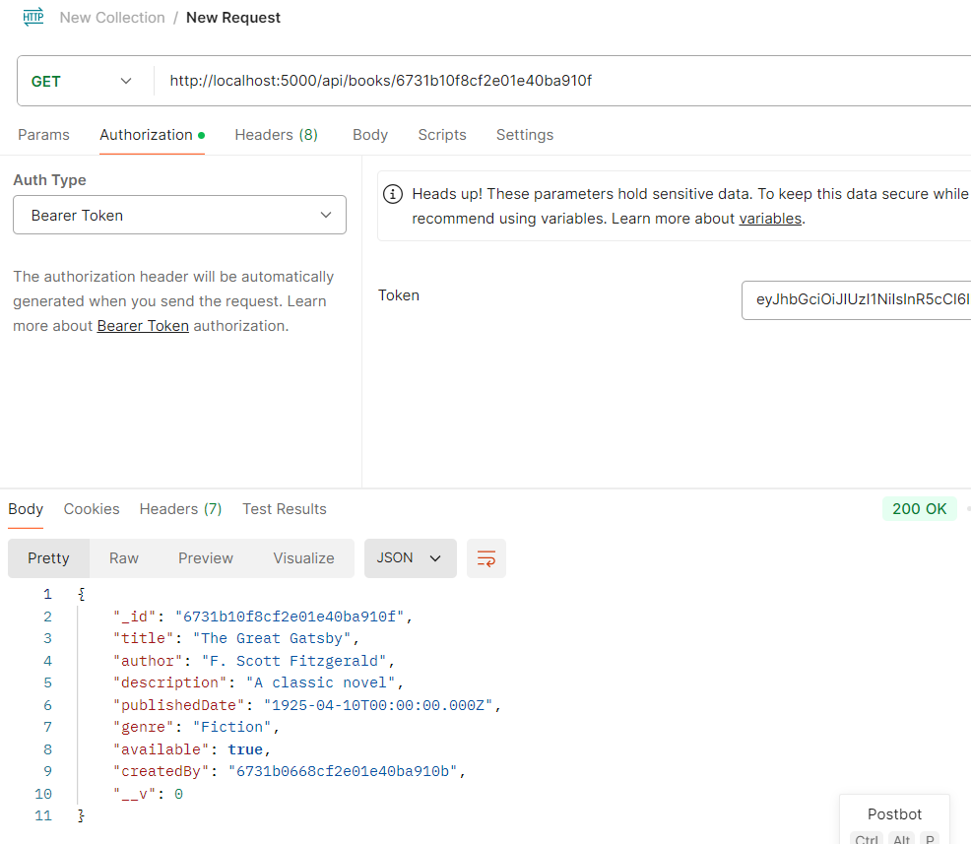

# Update Book

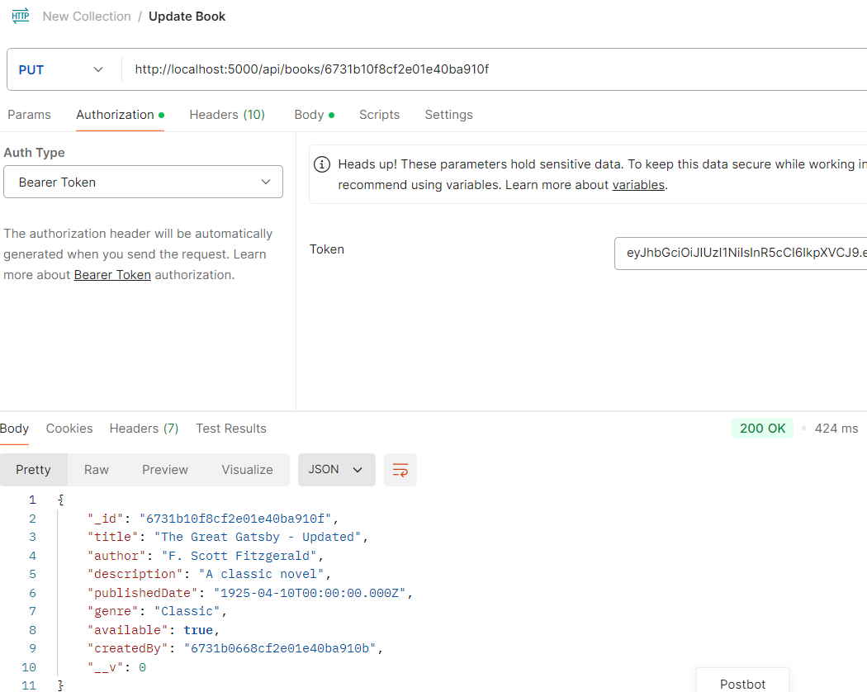

# Delete Book

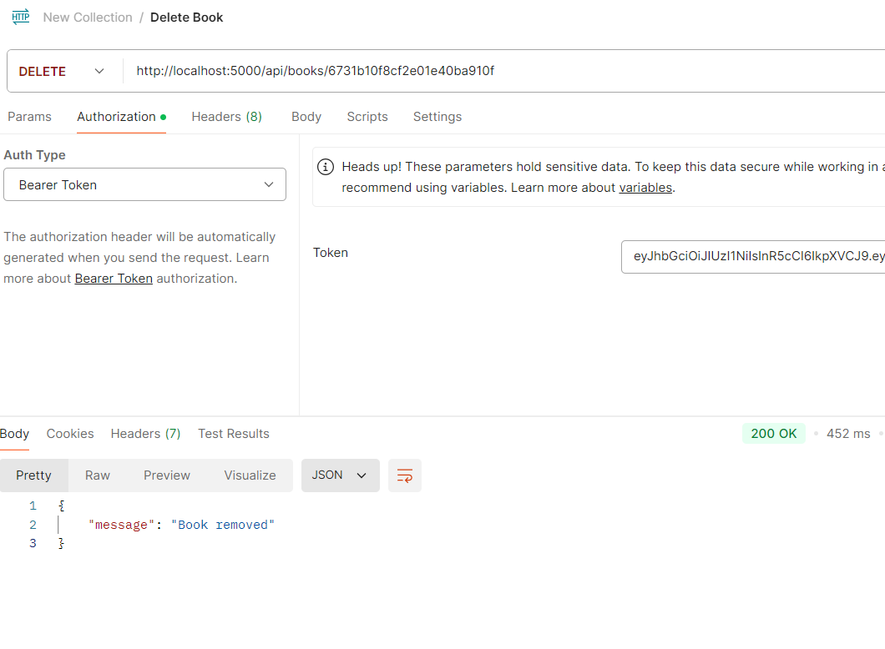

# Github URL

* <https://github.com/umarhaider552/Library>

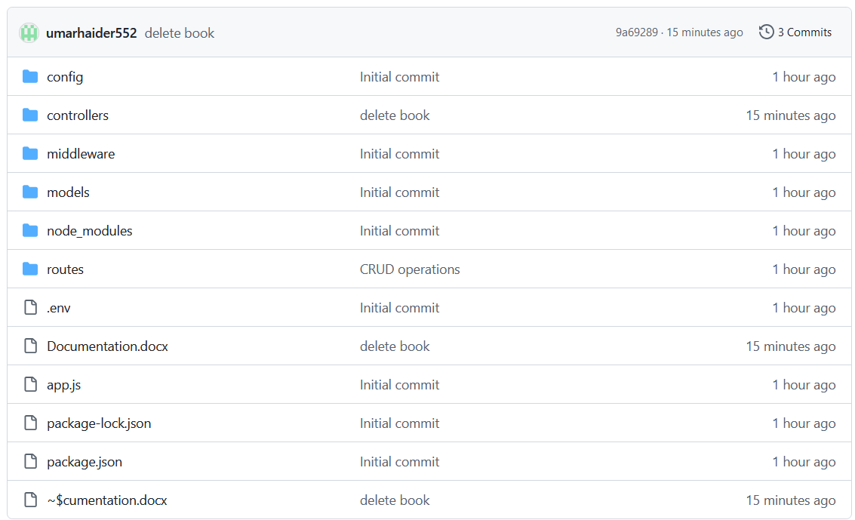

# Youtube URL

* <https://youtu.be/WvnZ8K1rHIM>

# Trello Dashboard

* <https://trello.com/b/VHXr8URQ/library>

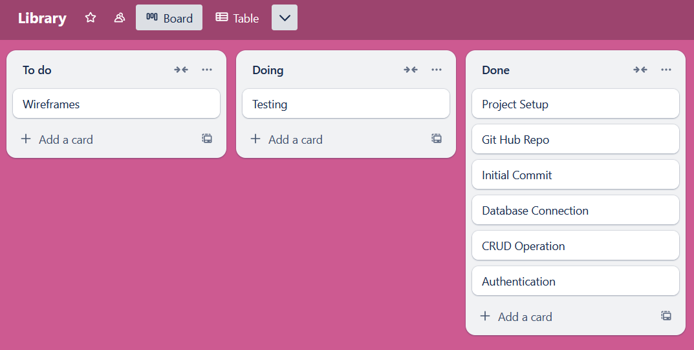

# Wireframes

